THE UTILIZATION OF THE SEA BUCKTHORN IN ROMANIA,
PAST, PRESENT AND FUTURE

By Doctorand Engineer PROOROCU ANGEL
UNIVERSITY of AGRICULTURAL SCIENCES and VETERINARY MEDICINE BUCHAREST FACULTY of MANAGEMENT, ECONOMICAL ENGINEERING in AGRICULTURE and RURAL DEVELOPMENT

Sea buckthorn, Euro-Asiatic specie, was classified in 1753 in “Speciae Plantarum” by Karl von Linné at the position 1023. The great botanist seems to be its godfather, Hippophae rhamnoides has two significations. Now, because it has a positive signification is accepted the etymology from Greek words: horse and shine. Romanian specialists demonstrate the influence of sea buckthorn which induces health for all animals, externalized in the aspect of their skin. The second signification is also from Greek, horse and poison, this is reflected in occidental Europe tradition. Romanian specialists’ conception at the beginning of the XX century was the same; it may be caudated by the plant’s negative effect. Other opinions are relative to the effect in elimination of intestinal worms. Romanian catina seems to become from Latin “catena”, the image from Romans invaders was a chain around rivers, the colour of leafs suggested them the silver. Its natural area was one of the largest of the world, from Atlantic Ocean to the Pacific, (fig. 1). Now it is also a subject of research programs in Northern and South America. If we consider Jawaharlal Nehru’s idea, that actual world situation is the result of the European domination in ancient social economical and military development; maybe sea buckthorn could have had another position in the history of plant utilisation.
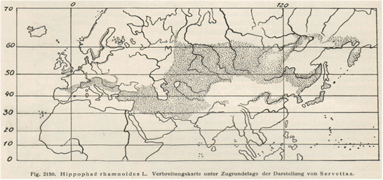
Sea buckthorn area from Illustrierte Flora von Mittel - Europa von Dr. Gustav Hegi Munchen J.F. Lehmanns Verlag 1926
In Romania, the modern scientific statute of agriculture started in the inter-war period when, in 1938-1943, Constantin Filipescu coordinated a large staff and published “The Great Agricultural Romanian Encyclopedia”. "Any country with pretensions of civilization must have in the cultural treasure agricultural encyclopedia and dictionaries needed by anyone who is concerned by this millenary activity"- said the author in the introduction. In the first volume of this work sea buckthorn was ample described at page 710: “cătina albă bot. Hippophae rhamnoides L. Fr. Saule epineux, germ. Sanddorn, engl. Sea buckthorn (sea, buck, thorn) bush usually 2-5 m. it may became a little tree of 5-6 m. from slippery grounds of river’s gravels. One year stems has silver scaly brush and ferruginous rust colored down, early they get thorns, old steams has a great number of short steams transformed in thorns. The ovoid buds are covered by a small number of golden yellow scales with silver brush. Leafs are linear lancelet or narrow oblongs 4-5 (6) cm. long and 5-6 (10) mm. breadth, short petiolated, petiole of 1-3 mm., entered edge; superior face at first has silver scales, at maturity dark green, glabrous and only the long of principal nervure with down, inferior face is silver with scaly silver thread to golden yellow which at friction are taken on the fingers. Dioeciously flowers are little, less apparent, greenish, situated on annual stems on which it appear simultaneous with leafs by 2-3 at the base of inferior leafs which are hiding integrally. Male flowers sessile with yellow-green perigonium on intern face have silver scaly thread in tubular form, evidently separate at the extremity in two lobs on square disk. Female flowers in raceme specula form, with a perigonium evidently separate at the extremity in two lobs, covered in exterior with scaly thread; unicarpelar pistil, one only box, with one ovule. Blossoms from April to May. Fruit is an achene covered in exterior with an induzion, seems that in the inferior part persists the perigonium which became fleshy. Fruit is ovoid like a pea bean brown-orange to golden yellow, the fleshy part has acidulous taste, contains a poisonous principia, witch don’t hinder birds to devour them after the snow fall. The pip, achene with solid brown shining cover, usually has one seed. The trunk may be strong developed 4-6m. and at soil level it may be 10-15 cm. in diameter with many ramifications has lateral direction, sinuously, covered at the beginning with brown smooth bark, in time it has a rhitydome dark brown scaly profoundly cracked. The hardwood yellow-brown, became by drying weighty, solid, may be polish, don’t resists in air, the ashes are rich in potassium. The striking root is profound, because the pivoted part penetrate depth the soil and superficial by lateral roots parallels with the surface, from lateral roots in sands there are starting many suckers. In roots there are tuberosities in which leaves in symbiosis an Actinomicete capable to assimilate atmospherically nitrogen. Is spread on marine dunes, alluvional sands along rivers and around lakes on stonily versants and crumbling bank, coasts and cliffs, detritus degraded pasture lands, etc. Its principal area is in Central Asia from Caucasian territory to North of Persia and Ural, to the East of Asia. In Europe it is along of Scandinavian coasts, in Baltic Countries to North Sea, South of England to the south of Europe vegetating on a narrow band on Mediterranean littoral in interior on vales in mountains or hills in North of Spain, South of France, North and Center of Italy, Yugoslavia, Down Austria, Hungary, South of Romania and Bulgaria. In our country Hippophae is in hills territories, Meridional and Eastern Carpathians valleys of versants from Moldavia and in Muntenia brings along valleys to field to the Danube. An insular center of sea buckthorn is in Danube Delta on Black Sea littoral in the place called Cardon at north of Sulina (5 km.). the optimum of its area is in under Carpathian zone of aflorisment of salifer, age Mediterranean inferior aquitanian in Ialomita valley, Laculete, Prahova valley and its affluent Campina, Comarnic, Telega, Slanic, Teleajan valley, Homoraciu, Buzau valley, Cislau, Nehoiasi, Ramnicu Sarat valley, valleys from Vrancea Country etc. and it continues in all basins to Bucovina. Utility in forestry for the fixing of dunes or moving grounds supports more salts in soil Na Cl, it may be the national essence for the restoration of Vrancea Country and other regions deforested from salifer under Carpathians in which the installation of forest on salt soils is difficult. Its ample ramification and numerous thorns make it valorous for hedges. As bush it is very ornamental also with its silver leafs and its numerous orange fruits and persists on branches after the snow fall. It may be multiplied by seeds, slips, marcotage and suckers.” Authors declared that the activity of elaboration of the encyclopedia was along the after first war period. I proudly may affirm the experience of Romanian specialists in the utilization of Hippophae rhamnoides in soil amelioration. In 2005 spring Romania has a great surface of flood. The economic phenomenon from the end of XIX Century when forests were destroyed and sailed for the construction of railways in Central Europe was the same in the legislative vide after 1990 and the situation in Romania is dramatic because the amplitude of destruction is incomparable. The mistake in the tackle of sea buckthorn is the attempt to define all varieties as one kind of assortment. It has a great variability and adaptability. Romanian researchers had demonstrated that the specie has the capacity to accumulate in it’s tissue a great level from some radioactive elements, characteristically for the soil and subsoil in its habitat zone. In soil and subsoil there are slowly transformations of radioactive elements, with variable times of halve which give to the crust a certain natural radioactivity. Alfa radioactivity results from the transformation of radium in radon, the beta radioactivity is given in special by the isotopic form of potassium being in soil near K40 ions. Romanian measurements of fruits in regions which are known with the particularity of radioactivity, established that there were 34-37 less alfa global concentration like the maxim admitted limit in potable water and 2-3 more beta radiations. This illustrated the capacity of fruits to indicate the presence of natural radioactivity in soil, there are storing of beta radiation from absorbed radioactive elements on soil particles or dissolved in soil solution. There are other species like Solanum nigrum, Romanian zarna, Veratrum album stregoaie which has toxic components influenced by the soil composition. These explain many contradictions about the benefice or lethal effect of fruit utilisation. The authors of the Romanian Encyclopaedia considered it like not recommended in feeding, their occidental formation and sources are explaining this opinion. Conclusion is that the variability of this specie is the motive of many contradictions about the concentration of components and the large utilisation of it. I think that International Sea buckthorn Association must be the promoter of a scientific map-drawing of varieties on the global areas first step for research in the various domains of utilisation. The regional people’s millenary experience in conditions of maintaining of environmental parameters must be an important yielding point in research activity. Hippophae rhamnoides L. has an opportunity to become the solution of the modern environment and feed global crises only in conditions of a global conception in research, integration of the production, processing, economic management and marketing.

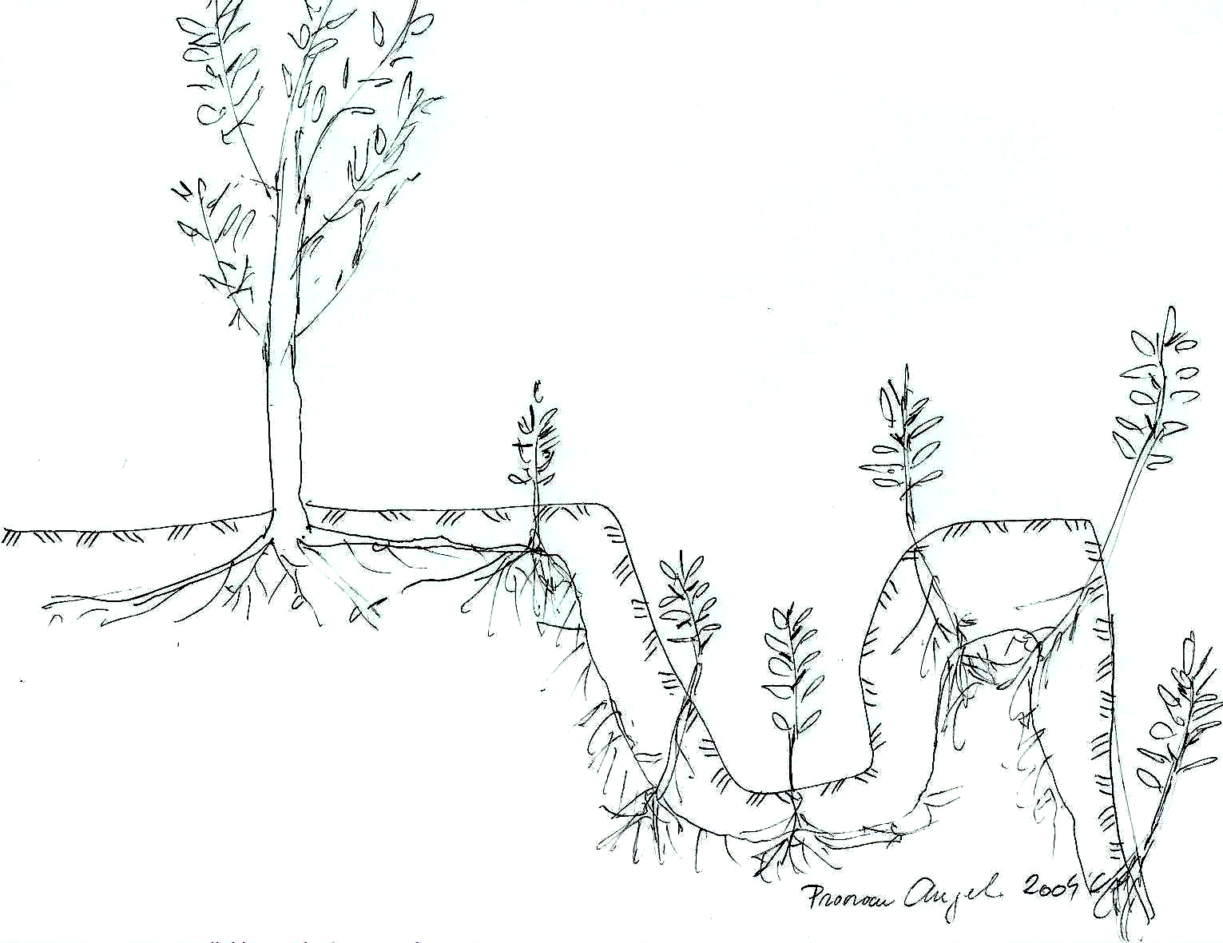

Fig. 2 From lateral roots there are starting many suckers. Proorocu Angel 2004

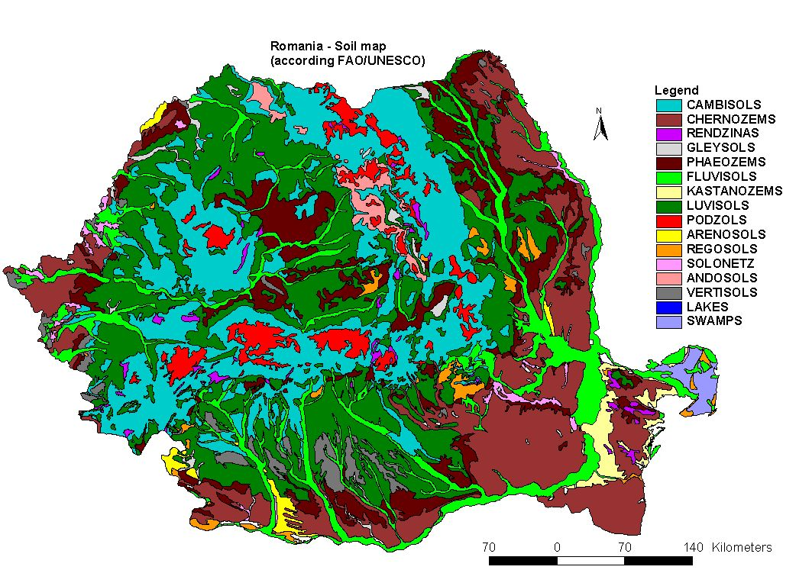

Romania has many natural resources in all domains of agriculture but we now are isolated, due to many causes, principals of them being corruption and the precarious management. This makes now sea buckthorn a solution like in China for the rehabilitation of soil, also a resource for the development of production of derivates. In Danube Delta a research program on 1450 ha. and other surfaces demonstrate the capacity of the plant to be utilized in soil erosion protection. Actual situation needs thousand of environmental plantations, possibilities of rehabilitation are certified.

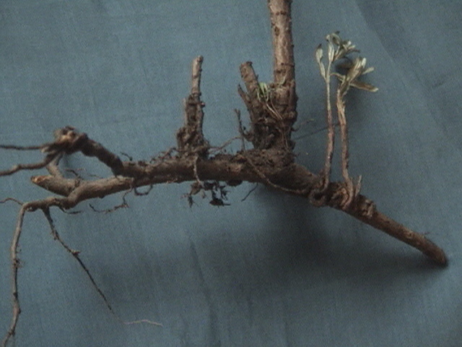
Fig. 3. The capacity of roots to generate many suckers. Proorocu Angel 2004.
Publicity, Advertising, Scientific Research, Legislation
^
Sale market Positive Effects
^
Food industries for the Environment
Fitofarmaceutics
Animal Breading
Cosmetics
Landscape
Soil amelioration
^ Air purification
Fruit production Meliferous Hedges
Fruit-growing Plantations, Anti-soil erosion and Landscape Plantations
^ ^
Planting and exploitation technologies
^

Planting Material
^
Technical and Economical Data Base
Fig. 4. Schematic presentation of principal aspects which are logically necessary for the scientifically implementation of sea buckthorn utilisation in Romania.

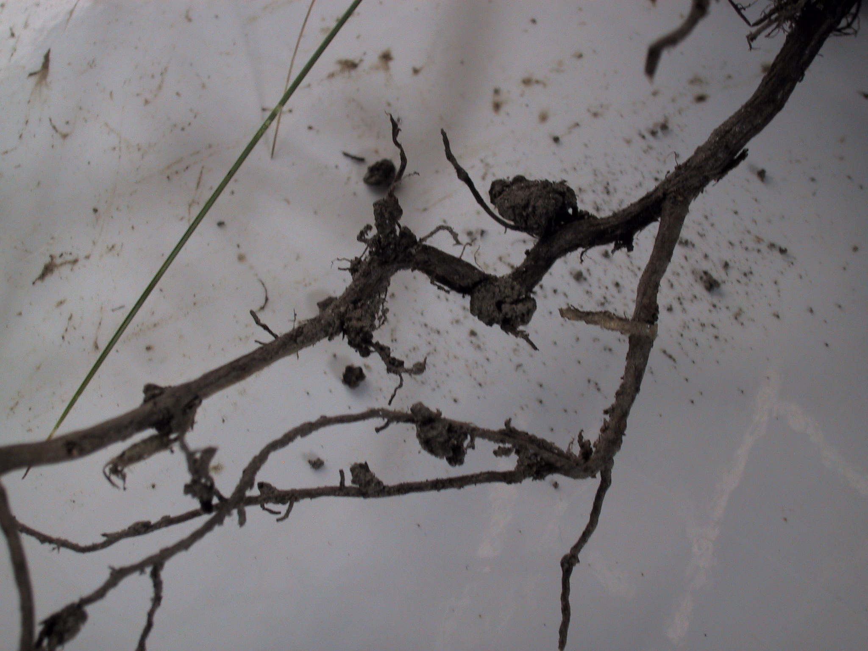
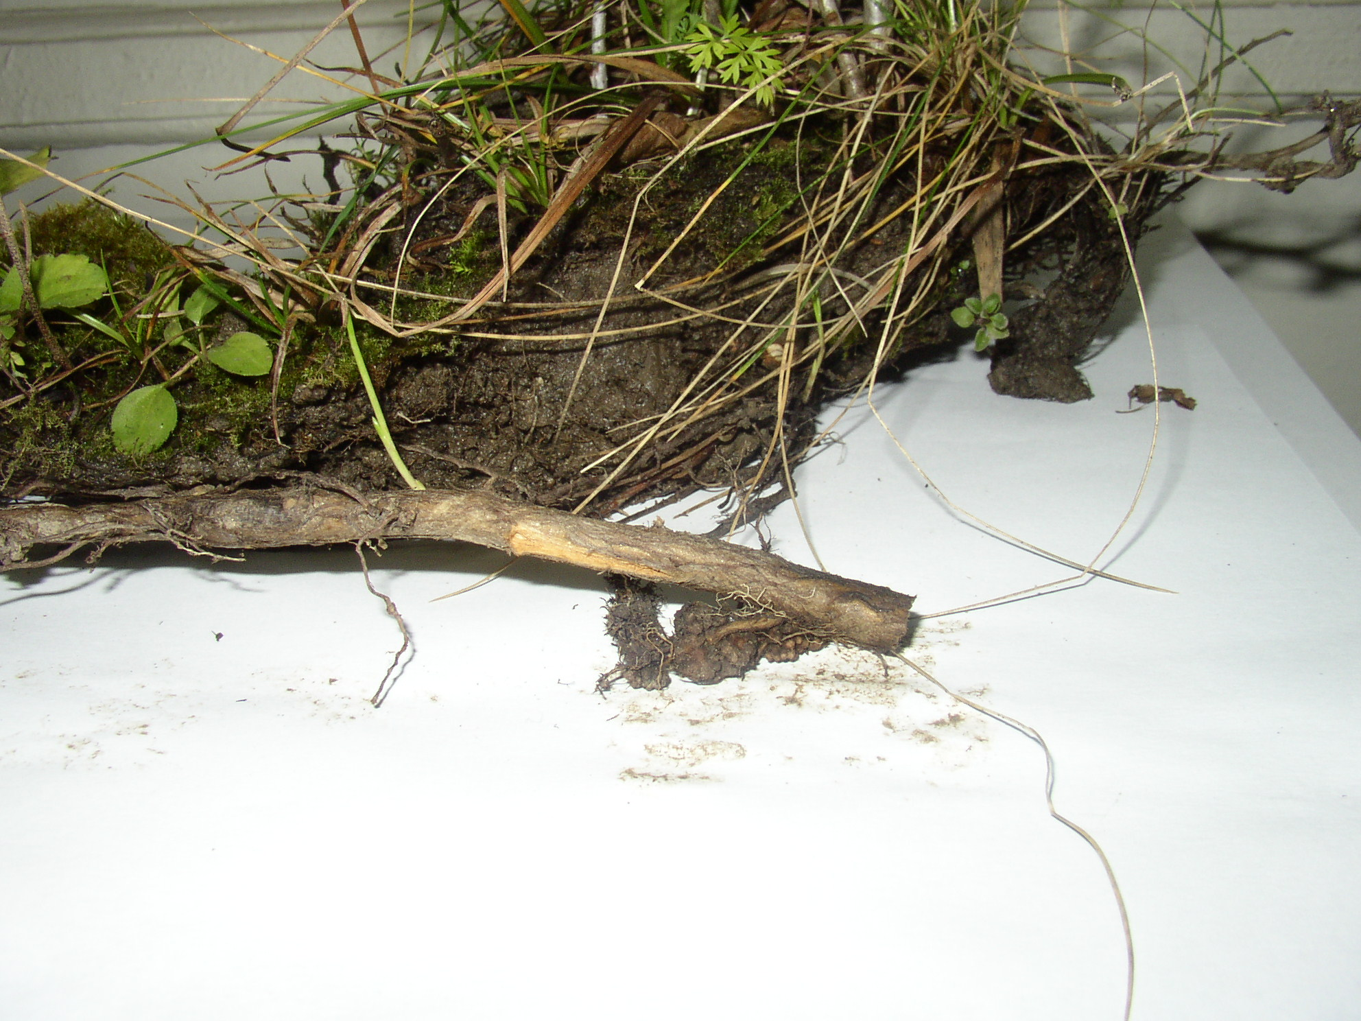

Fig. 5. Aspects of sea buckthorn roots with Frankia nitrogen fixing symbiosis nodule. Proorocu Angel 2004.

Sea buckthorn is called by the Romanian peasants in Buzau county “berries of the Holy Virgin”. Romanian people used from hundred of years the fruits for the treatment of anaemia, diarrhoea, rheumatism and rash. From fruits they obtained many products in feeding: juice, vine, jam (with cherry, apples and plums), butter etc., they used it as textile colorant. In Romanian “Medicinal and Aromatic Plants from A to Z” guide book, the two appreciate specialists Ovidiu Bojor and Mircea Alexan recommend sea buckthorn as vitamin complex ( C, B1, B2, PP) carotenes, folic acid, oil, izoramnethol, fitosterol. Recommended in avitaminose Fructus Hippophae in combination with Fructus Cynosbati (hip rose), Folium Urticae (stinging nettle), gooseberry, Folium Menthae (mint), Folium Rubi idaei (raspberry) and Folium Primulae (cowslip), infusion, cooling drinks, syrups, gout as reach in vitamins and diuretic, pneumonia in combination with colt’s foot, linden tree, hyssop, cowslip, savory, elder tree, rickets Fructus Cynosbati (hip rose), Fructus Hippophae, Folium Primulae (cowslip), Folium Melissae (balm mint), adjuvant in pulmonary tuberculosis in winter and spring for vitamins with Fructus Cynosbati (hip rose), Folium Urticae (stinging nettle), Folium Primulae (cowslip), uremia in combination with diabetes Folium Betulae (birch tree), Folium Myrtilli (bilberry) and Herba galegae (goat’s rue), xerophthalmia in combination with Fructus Cynosbati (hip rose), Folium Urticae (stinging nettle), Flores Tagetes (marigold) and Fructus Myrtilli (bilberry).
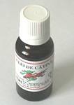
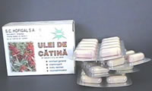

Fig. 6 Variety of Sea buckthorn oil products of S. C. HOFIGAL S. A. from Romania
PRODUCTS PRESENTATION:
Phials with 10 ml; 20 ml ; ±3%, 100ml; 500 ml; ±2% or capsule with 0,4 or 0,6 ml sea buckthorn fruit oil the active principia extracted through an original proceeding being a natural food concentrate. Liposolubil components of the sea buckthorn oil represent a polivitaminic complex with regenerating action for the cellular metabolism. Active principia contained are, in principal ß- carotenes, vitamins D, E, F, K, therefore all liposolubil vitamins, also o series de polifenolic products strong anti-infectious. Also contains lecithin in easy assimilability forms (calcium and magnesium salts), unsaturated feet-acids like ß-linolic acid as precursor of a lot of organic enzymes.
ACTION: general tonifiant, antianemic, vitaminizant; imunomodulator; synergic action with interferon; contribution for the syntheses of proteins raw-material for interferon; coronaries protector; antiaterosclerotic; slowing down the process of ageing by consumption of undesirable free radicals; detoxifying the liver and assure the trofic function for the hepatic cell; anticancerigen by the great contain of ß-carotene; in extern administration good for cicatrizing, dermoregenerator effect, anti-inflammatory, nutritive; excellent protector against solar radiations or de other nature.
INDICATIONS: Intern use: Prophylactic: slowing down the process of ageing and anticancerigen, tonic general in stress situations, imunomodulator. Adjuvant: intern treatment of some dermatological affections (psoriasis, LED cutanate forms), ORL affections with component atrophic and inflammatory, cardio-vascular affections being a good coronaries protector affections ale digestive system. Active in chronic hepatitis, uro-genital affections, neurological psychical affections, antianemic, excellent role in slowing down of some ocular affections (hemeralopia, presbytism, keratomalacie, myopia, astigmatism, hipermetropy, glaucoma, cataracts) being rich in ß - carotenes.
Extern use: local treatment of eczema, thermal and chemical burns, chilblains, alergodermias, psoriasis, lent recovery wound. It is the only natural product recognised for the activity of protection against solar radiations or other nature.
Cosmetically use: antirid and nutritive creams, gels and lotions of protection and maintenance for all kinds of skin.
S.C. CCPPM Plantavorel S.A. Piatra Neamt, continue the traditions of Vorel pharmacists family which in 1880’s initiate Green Pharmacy, in 1942 produced 120 products. In 1948 it was nationalised. In 1983 Plantavorel Laboratory initiates new research and production in utilisation of Romanian “Green Gold’. Now there are sea buckthorn homologated products “Cevisol”, natural dietetic and food supplement extract of fruits. Tonic general, for children, convalescents, intellectual and physical effort. “Vorisol granule” natural dietetic and food supplement extract of fruit extracts of Hippophae rhamnoides and Rosa species. Granules may be used also like tea, 2 spoons at 100 ml. water. There is “Hebe radix” protection cream extracts of sea buckthorn, marigold and blackwort, volatile oil of mint, excipients, conservants. Recommend in solar and thermo burns, contact dermatitis, etc. Research programs recommend plants from “Curvature Carpathians” as optimal for pharmaceutical products.
Ioan Lupe, Romanian forestry specialist had modern initiative in sea bukthorn utilisation. In the work „Pomicultura generală şi specială Editura Didactică şi Pedagogică 1982, authors Popescu M. and other pomologists presented the first tehnology and presentation of sea buckthorn, now the research is focalised on conservation, evaluation and development of genetic resources, establishment of plantations with suitable varieties, identification of new valuable genotypes, analyses of biochemical fruit characteristics, studies of physical and chemical soil improvement, and studies of symbiotic association between the plant and fungi and bacteria. Unfortunately this plant was never abordate in a global conception in Romania; this made it a permanent a theoretical resource.
The abordation must be in two directions of implementation in romanian agricultural sistem: horizontaly: plantations on large surfaces on degradated soils, erodated, salins, etc.; verticaly: creation of a data base, of some productive centers, biological material selected devize, sistems of plantation, tehnologyes, a sistem of processing of the production, diversification, creating a large game of utilisations and obtaining economical superiour results, competitive products for export creation of an informational sistem and publicity for sea buckthorn products, chainging mentalities and wrong treatments with artificial products. ( fig. 4.)
CONCLUSIONS:
This plant is fixing lands which are most degraded (has many suckers), assimilate atmospherically nitrogen directly by roots (has an ameliorative effect to the soil), Frankia is the bacteria which is responsible of this quality estimative it is considered a volume of 2 – 179 kg. N / ha/year.
In modern pharmaceutics it is also used in cosmetics, many treatments and for burned and irradiated tissues. In the feeding of domestic animals were used some products, for the aspect of the hair of dogs, cats, and horses, the quality of eggs and the immunity.
Plants are used like decorative plants and hedge; their green-white colour is in contrast with the orange of flowers and fruits.
Lupe Z. Ioan, Grigorescu Emanoil, Brad Ion, Cireasa Victor, Manea Stefan are some of Romanian specialists in forestry, horticulture, medicine, bio-chemistry with many studies and applications of sea buckthorn as we can see in the summary attached bibliography .
In Romania Hippophae rhamnoides L. was the object of many national research programs, now it was abandoned. Now there are not serious investitures and are not mobilized foreign institutions which may use modern instruments for the obtaining all advantages of this plant.
Some institutions and industrial units continue the tradition with good results, but I think that is not the level which is possible in the actual potential of Romania. It must be a solution of the rehabilitation of thousand of hectares of Romanian denuded grounds.
I am preparing a doctorate thesis: “Studies about the importance of sea buckthorn (Hippophae rhamnoides L.) in the environmental protection and human health economy”. I am presenting solutions for the implementation of the plant but in Romania it is difficult to be initiating a national programme in this domain at this moment when the national interest is inexistent. My country is considered to be the place where many vegetables have some conditions which made them most good like in other regions, sea buckthorn is one of them and here it has a great variability. The Romanian biotypes fruits contain a lot of vitamins, 2 x vitamin C like hip roses, carotene, citric acid etc. The oil contains E vitamin which is revitalizing the human organism, near vitamins P, B1, B2, A, K, F ( F vitamin defend cells of cancer and irradiation, there are also 15 microelements Fe, Mn, B, Al, K, F, Ti etc. From fruits it is possible to obtain many products in feeding: juice, vine, jam (with cherry, apples and plums), butter etc. All products are very rich in vitamins.
Plants of Hippophae rhamnoides L. are valuable like decorative plants; their green-white color is in contrast with the orange of flowers and fruits, it is a melliferous plant, aspect important in its polenisation.
Interesant is the EU-Project G5ST-02-71999, SEABUCK Innovative products obtained from fruits of Sea buckthorn (Hippophae rhamnoides). Milestones of Seabuck project funded by the European Commission are:
- optimisation of the extraction, purification and stabilisation tehnology for caroteno-lipoprotein complex from Sea buckthorn fruits;
- detailed analysis of obtained caroteno-lipoprotein complex on chemical composition, stability and activity;
- large scale realisation of the extraction and purification tehnology for the caroteno-lipoprotein complex at one of the participating tehnology companies and estimation of the production costs;
- development of three different cosmetic products containing the Sea buckthorn caroteno-lipoprotein complex ready for commercialisation
- sensory and dermatological trials of the developed cosmetic products.
In my conception International Sea buckthorn Association has an important role in the future development of Romanian evolution, the natural potential of Romanian biotypes may be integrate in research and production programs, international collaboration, creating a world data base in research, commercial and technological domains. In Romania must be initiate an environmental and food and health program, the logical succession of problems was presented in fig.4, there are many problems, one of them being the resistance and opposition of artificial producers of food, juice, syrup, vitamins etc.

BIBLIOGRAPHY:
- Alexan M., colab. - Flora medicinală a României vol. I şi II Editura Ceres 1992.
- Berca M. - Ecologie generală şi protecţia mediului Editura Ceres 2000.
- Bojor O., Alexan M.-Plantele medicinale şi aromatice de la A la Z Editura Recoop, Bucureşti Ed. I –VI 1982 – 1999
- Brad I., colab. – Cătina albă – o farmacie într-o plantă Ed. Tehnică 2002.
- Ciocârlan Vasile – Flora ilustrată a României Editura Ceres 1988
- Cireaşă V., Năstase M. - Cercetări privind comportarea arbustului fructifer Hippophae rhamnoides în vederea introducerii acestuia în cultură Lucrări ştiinţifice I.A.N.B. vol. II, Bucureşti, 1979
- Constantinescu C. - Plantele medicinale din flora spontană, Recoop 1973
- Crăciun T. - Genetica şi societatea Ed. Albatros 1983
- Duţă V. - Medicina naturistă Editura Lumina Lex 2003
- Filipescu C. - Marea Enciclopedie Agricolă vol. I Bucureşti 1937
- Grigorescu E.- Contribuţii la studiul farmacogenetic şi fitochimic al speciei Hippophae rhamnoides L. indigenă. Teză de doctorat, 1963
- Haralamb A. - Cultura arbuştilor fructiferi Editura Agrosilvică 1969
- Hodişan V. - Curs de botanică farmaceutică U.M.F. Cluj Napoca 1993
- Istudor Viorica - Farmacognozie, fitochimie, fitoterapie Editura Medicală Bucureşti 2001
- Lupe I. Z. - Perdele forestiere de protecţie şi cultivarea lor în câmpiile din România Editura Academiei R.P.R. 1952
- Manea Şt. Cătina şi uleiul de cătină, aliment, miracol, sănătate, echilibru S. C. Tridona S.R.L.
- Mihescu G. - Fructele în alimentaţie, bioterapie şi cosmetică Editura Ceres 1994
- Mocanu St. colab. - Plantele medicinale, tezaur natural în terapeutică Editura Militară 1986
- Mohanu Gh. Tratarea bolilor cu plante medicinale Editura Corint Bucureşti 2003
- Negruiu F. - Spaţii verzi Editura Didactică şi Pedagogică 1980
- Negulescu E.G., colab. - Dendrologia Editura Agrosilvică 1965
- Pârvu C. – Enciclopedia plantelor – plante din flora României vol. I Ed. Tehnică 2001.
- Petrescu F. - Garduri vii Editura Ceres 1987
- Popescu M., colab. - Pomicultura generală şi specială Editura Didactică şi Pedagogică 1982
- Proorocu A. Folosirea cătinei albe (Hippophae rhamnoides L.) pe terenurile degradate din România Universitatea de Ştiinţe Agricole şi Medicină Veterinară - Bucureşti – 2000.
- Proorocu A. Importanţa cătinei albe (Hippophae rhamnoides L.) pentru protecţia mediului, Agricultorul român, anul VII, nr. 3 (75), martie 2005, pag. 26-27.
- Rovenţa I. Peisajele sănătăţii – plantele medicinale în decorul parcurilor şi grădinilor Editura RECOOP Bucureşti 1975
- Sansavini S. - Fruticultura alternativa con le specie minori Edagricole 1995 Bologna.
- Sonea V. Palade L. Iliescu A. F. - Arboricultura ornamentală şi arhitectura peisageră, Editura Didactică şi Pedagogică Bucureşti 1979.
- Traci C., Mănescu M., Drăguţ N. - Împădurirea nisipurilor din Delta Dunării - tehnologii Redacţia de Propagandă Tehnică Agricolă
- Illustrierte Flora von Mittel-Europa von Dr. Gustav Hegi Munchen J.F. Lehmanns Verlag 1926
- Carte de la Végétation naturelle des Etats Membres des Communautés Européennes et Conseil de l’Europe – Office des Publications Officielles des Communautés Européennes L 2895 Luxembourg
- www.catina.tk , , www.plantavorel.ro , www.terminfo.go.ro .

