Seabuckthorn breeding on eco-economic improvement purpose

—Superior plant selection in F1 generation
of ssp mongolica and ssp. sinensis

Jin Zhengpin Wen Xiufeg Lun Shunguang Jin Shuyuan
China Administration Center for Seabuckthorn Development (CACSD)
wenxf@icrts.org

It has been well know that the genes’ newly combination will result much variation within the filial generation, so the fine plant selection standards has been established based on the study of genetic character variation in F1 generation population which got by hybridization between ssp. mongolica and ssp. sinensis. 3 fine plant has been selected from 1500 female plants of filial generation population. 3 of them are with both parents advantages: like as growing is much better than parents and local sinensis; without any irrigation, the fruit size and fruit productivity of plant is much higher than average value of filial population, female parent and local sinensis, the selection intensity of fruit productivity is 3; the thorns are significantly less than selected population and siensis; the fruit with higher quality, especial oil and Ve content. But under water intimidate, the fruit productivity will be influenced, so forth more trails on resistance to hard ecological conditions of selected trees need done on different plantation sites.

Key words: ssp. sinensis, ssp. mongolica, F1 generation, genetic variation, superior selection

Seabuckthorn is one of the most magical plant resources with higher value of economy and ecology. In China, the state input on seabuckthorn plantation for soil and water erosion control and environment improvement in semi-arid areas of north hills the gulls, at same time, the farmers get more income by seabuckthorn fruit harvesting, and the processing companies achieve a great industry profit by seabuckthorn products.
Seabuckthorn plantation area is more than 1.5 million hm2, but almost all the seedling are seedlings of spp. sinensis, which are with strong resistance to dry weather and poor soil conditions, with rich bio-chemical substances in fruit ^{[1][2]}, but it has a small fruit size, short pedicel and heavy thorns^{[3]}.
The advantage features of ssp. mongolica, mainly distributed Russia, Mongolia, especially the superior varieties selected form their population, are with big fruit size, long pedicel, more yield and less thorns as well as easy for harvesting ^{[4][5][6]}. Since later of last 80’s , a large number of seabuckthorn cultivated varieties have been introduced from Russia and Mongolia, which have been proved that the introduced varieties were easy to be infected by pathogenic bacteria and insects, not suit to the arid or semi-arid climate in north and north west of China. So the first thing the breeders take consideration is how to use these rich seabuckthorn resources in breeding programmer.
Since last 80’s, the seabuckthorn breeding has achieved a great achievement by three ways, first one is research to the natural seabuckthorn resources distributed in China, and got the superior provenance by provenance trails, and also got some superior families and then established their progeny testing plantations ^{[1] [2]}. The second way is introduction, lots of cultivated seabuckthorn varieties were introduced from Russia and Mongolia, most of them are ssp. mongolica, some cultivated varieties have been practiced in cultivation after selection and clone trails. The third is now we did is hybridization between sub-species (ssp. sinensis and ssp. mongolica).
This paper introduced one of the hybridization and superior plant selection in F1 population.

- Hybridization method

  - the objectives of hybridization breeding
The concept of eco-economy breeding was proposed based on the Chinese condition: great
population, less cultivated lands ^{[12] [15] [16]}. The objectives of this research is to achieve the superior plants by selection from F1 population of ssp. sinensis and ssp. mongolica, which are with big fruit size, less thorns, rich bio-substances as well as with higher capability to resistance hardy eco-condition ^{[14]}.
  - Material selection
    - Female parent
“Wulanshalin” as the female parent is the clone selected from the seedlings of “Ulanugon”
with the features as following. Tree height is about 1.5-2m, the shape is bush like, fruit colour is orange-yellow, the pedicel is 4 mm long, the 100 fruit weight is 50 g growing under better soil and water, single plant yield is about 5 kg, almost no thorn on branches, the leaves long is 5-6 cm, the width is about 8-9 mm.
    - Male parent
“Fengning” as the male parent is the superior eco-type selected from the ssp. sinensis population of Fengning, Heibei province. It’s height is about 2-2.5 m, bush’s shape, less thorns, leave’ longs 5-6 cm, width is 8-9 mm.
  - Hybridization
1.3.1 Sub-species of sinensis and mongolica have a corresponding florescence period in China, so the artificial pollinated was done in 1997, and the seeds of F1 were gotten by hybridization, about 5000 seedlings gotten in 1998.
1.3.2 F1 progeny testing plantation
In 1999, the F1 testing plantation established at seabuckthorn breeding base of Jiuchenggong, Inner Mongolia (Picture 1). Total 4900 plants were planted in 1m×3m way, about 1.5 hm². The soil within 2 meters deep are sandy soil which are poor for water preserve. The under ground water is beyond 2 m, the water content in soil is so low. Under such poor condition, the F1 seedlings not only can grow well but also can bloom and bear fruit well.
3056 plant preserved in 2003, the preserved rate is 62%, male and female plants is 1 to 1, most plants grow well in progeny testing plantation.

- Method of superior plant selection
In 2002, the F1 population began to bear fruit. In 2003, most of the plants had a certain yield.
The superior plant selection are established base on the study of F1 population phenotype’s variation.
2.1 Features of phenotype and variation of F1 population
The research objectives are followings: 50 female sample plants from F1 population, 10 plants from female parent clone population, and 50 female plants from local sinensis artificial plantation. The value of phenotype features from different populations are shown in the table 1. The Fig 1, Fig 2, Fig 3, Fig 4, Fig 5, Fig 6 shown the frequency of phenotype’s features from different population.

Table 1 Phenotype features of populations（2003, 2004）
 | F1 population | Female | sinensis population
Heiht（cm） | 222 | 132 | 161
Crown diameter（cm） | 186 | 150 | 172
Thorns（thorns/10cm） | 1.34 | 0.2 | 3.5
Fruit long (mm) | 8.0 | 8.7 | 5.9
Fruit shape coefficient | 1.03 | 1.19 | 0.98
Pedicel long (mm) | 3.0 | 3.7 | 2.0
100 fruit weight (g) | 26.2 | 28 | 11.8
Yield (kg/plant) | 0.92 | 1.2 | 1.08
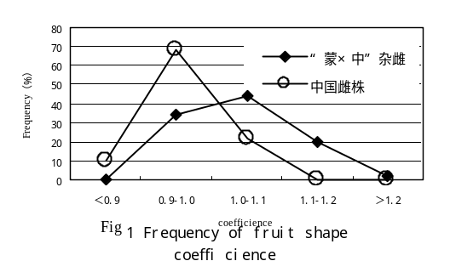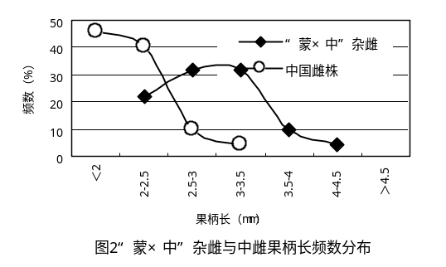
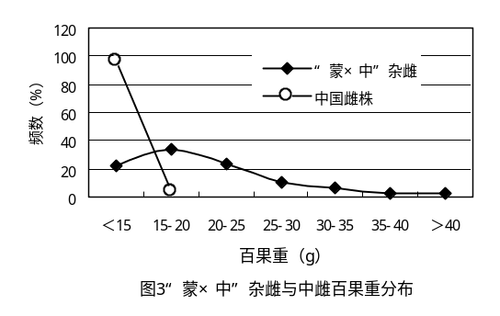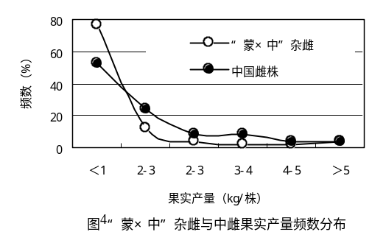
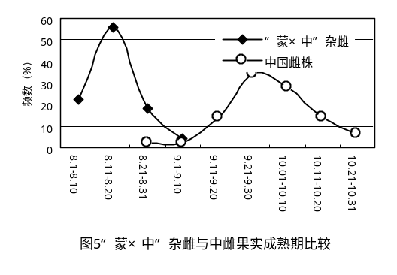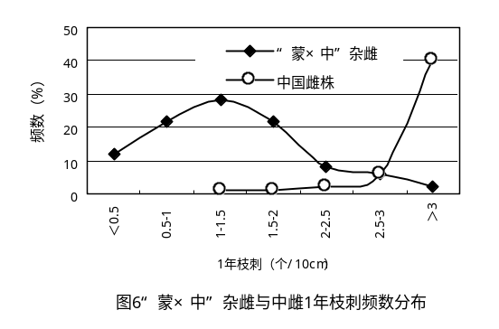
The figures above showed that the phenotypes have much variation because of gene re-combination from male and female parents in the F1 population. The plant height and growing power of filial plants are more stronger than parents population, about 84% of F1 plants, 100 fruits weighs over 20g, (sinensis only 4% plants ) and 78% of F1 plants, the pedicel is longer than 2.5 mm, (14 % only in sinensis). And 84% plant in F1 population, the thorns density is less than 2 thorns /10 cm, (only 2% plants in sinensis). And no disease infected plants had been found in the F1 population. Table 2 is the phenotype CV values of F1 and local sinensis population.
Table 2 CV (%) values of phenotype
Features | F1 population | sinensis population | Average
Height | 19.9 | 20.9 | 20.4
Crown | 19.6 | 19.5 | 19.6
Ground diameter | 22.4 | 33.9 | 28.2
Fruit length | 9.9 | 9.7 | 9.8
Fruit width | 8.3 | 8.8 | 8.6
100 fruit weight | 22.7 | 23.6 | 23.2
Pedicel | 17.9 | 19.6 | 18.8
Yield | 176.5 | 107.5 | 142.0
Thorns on fruit branch | 53.3 | 19.2 | 36.3

From this table, we can find that some features have a great variation in seedlings plantation, for example the productivity of plant and the thorns on new sprouts. It means we can get more better plants with great improvement on these phenotype features. But it is difficult to choose ones with other features, especially the improvement on fruit size and long pedicel.

2.2 The criteria of superior plant selection
But as a matter of fact, it is impossible for us to get single plant excellent enough to be with every features best. So according to the degree of importance, we gave the different weight to some key features: 0.1 to volume of tree, 0.3 to plant productivity, 0.3 to 100 fruit weight, 0.1 to fruit pedicle and 0.1 to thorns on new sprout. we got the comprehensive selection index, and put them in order (table 3)
Table 3 Front 10 plants in comprehensive selection index list
 | Volume of crown（m³） | yield  （kg） | 100 fruit weight  （g） | Pedicel  （mm） | thorns  （thorns/10cm） | Selection index
1 | 5.2 | 1.910 | 24.90 | 3.4 | 1.64 | 0.406
2 | 5.4 | 0.870 | 35.70 | 3.2 | 1.21 | 0.427
3 | 4.4 | 2.600 | 21.00 | 3.3 | 0.29 | 0.438
4 | 5.0 | 2.500 | 27.20 | 3.1 | 1.25 | 0.445
5 | 5.1 | 1.800 | 29.80 | 4.1 | 0.89 | 0.455
6 | 5.2 | 0.050 | 27.00 | 3.4 | 0.06 | 0.519
7 | 5.9 | 1.700 | 43.70 | 3.6 | 0.25 | 0.576
8 | 6.2 | 5.000 | 30.60 | 3.2 | 1.44 | 0.610
9 | 4.4 | 5.200 | 35.80 | 2.7 | 0.34 | 0.652
10 | 7.0 | 5.900 | 28.80 | 3.2 | 0.66 | 0.660

But the comprehensive selection index is not the only criteria for our selection. For example, the No. 7 is with bigger fruit size, less thorns, and the pedicel is longer, but the productivity is lower; the No. 8 is with bigger fruit size, higher yields, but the thorns are heavy. So we have done the regulation to the criteria based on our breeding objectives (Table 4).

Table 4 Criteria of selection of “ mongolica ×sinensis”
Traits | Volume of crown  （m³） | Weight of 100 berries  (g) | Productivity  (kg/plant) | Pedicel  (mm) | Thorns  （thorn/10cm）
Standard | ＞4 | ＞30 | ＞5 | ＞2.5 | ＜1

3. Superior plants selected
3.1 Comparison of phenotype features between filial and parent populations
In filial population, 3 superior plants (plus tree) have been selected, the ration of selection is 1/500 (0.002).
Selected plant No1 is with form of low bush, 170 m high, with open crown and harder branches. It is most like male parent, its fruit is ball-shape with dark yellow colour, the mature time is middle of August (Picture 2).
Selected plant No10 is with the form of small arbor tree, 230 m high, with dense branches, its fruit are ball like, orange colour, the mature time is about August 10, more feature are like the female parent, less thorns (Picture 3).
Selected plant No12 is form of bushes, 220 m high, open crown, the fruit are ball like, with light orange-yellow colour, the mature time is middle of August, more fruit branches (367 branches) , less thorns (Picture 4).
Table 5 is the information about the features of selected superior plants, female parent, and local ssp.sinensis population.

Table 5 Phenotype features of selected superior plants (August, 2003)
Selected plants or Population | height  （cm） | Average crown  （cm） | Value of crown  （m³） | Weight of 100 berries  (g) | Pedicel (mm) | productivity  （kg） | thorn（thorn /10cm）
No. 1 | 170 | 186 | 3.1 | 41.2 | 3.0 | 7.4 | 1.3
No.10 | 238 | 189 | 4.4 | 35.8 | 2.7 | 5.2 | 0.34
No. 12 | 220 | 233 | 6.2 | 30.6 | 3.2 | 5.0 | 0.90
average | 209 | 202 | 4.5 | 35.9 | 3.0 | 5.9 | 0.85
F1 population. | 222 | 178 | 5.1 | 26.0 | 3.0 | 0.84 | 1.4
Female | 132 | 150 | 1.6 | 26.0 | 4.7 | 0.10 | 0
Sinensis population | 161 | 172 | 2.7 | 13.9 | 2.0 | 1.5 | 3.5

In one word, we gave a summary to selected superior plants, (1) the plant growing is close to the filial population, but obviously better than female population and local sinensis; (2) during the rich raining years, without irrigation condition, the fruit productivity is significantly more than filial population and female and local sinensis population; (3) the thorns are not less than female parent, but much less than filial population and local sinensis.

3.2 Composition analysis of superior plants
In August 2003, the fruit of selected plants and local Chinese seabuckthorn were collected as the analysis samples, the analysis results are as follows.

Table 6 Vitamins content of selected plants and sinensis (mg/100g)
 | Vc | Ve | β- carrotene | Total amino acids
No.1 | 117.0 | 17.45 | 1.89 | 492.5
No.10 | 313.4 | 10.19 | 6.05 | 489.6
No.12 | 277.5 | 6.20 | 3.00 | 532.2
sinensis | 444.5 | 2.25 | 3.09 | 634.0

Table 7 Content of fruit oil and seed oil (%)
 | No. 1 | No. 10 | No. 12 | sinensis
Fruit oil | 3.9 | 2.9 | 4.2 | 1.4
Seed oil | 9.1 | 9.4 | 5.7 | 6.7

Table 8 Fatty acids in fruit oil (%)
 | Palmitic | Palmitoleic | Stearic acid | Oleic | linoleic | linolenic
No. 1 | 37.8 | 32.8 | 1.60 | 18.1 | 7.5 | 0.65
No. 10 | 40.3 | 35.2 | 0.98 | 13.5 | 8.0 | 0.74
No. 12 | 36.8 | 37.4 | 0.84 | 13.0 | 9.7 | 0.70
sinensis | 27.6 | 29.4 | 0.41 | 18.6 | 6.2 | 0.95

Table 9 Fatty acids in seed oil (%)
 | Palmitic | Palmitoleic | Stearic acid | Oleic | linoleic | linolenic
No. 1 | 11.3 | 4.3 | 2.24 | 21.6 | 32.2 | 26.8
No. 10 | 9.9 | 3.4 | 2.02 | 19.1 | 29.7 | 33.2
No. 12 | 14.2 | 8.4 | 1.32 | 13.5 | 26.6 | 25.3
sinensis | 17.3 | 7.9 | 0.79 | 19.4 | 28.1 | 20.7

From the tables, we can find that (1) Vc of selected plants are obviously less than local sinensis, No. 1 only 26% of sinensis, No. 10 is highest in 3 selected plants, 70.5% of Chinese seabuckthorn, but Ve is much higher than sinensis, the highest No.1 is nearly 8 times of sinensis, the lowest No. 12 is over 2 times of sinensis. The content of carotene changes with the colours of fruit, and the total amino-acids are all less than the content in fruit of sinensis. (2) the fruit oil and seed oil are much higher than local sinensis fruit, content both fruit oil and seed oil have gotten a better improvement in the selected plants. The composition of fatty acids in oils have a difference, but no much found compared with that in sinensis. (3) every composition are changeable within different population and different plants either. The bio-chemical composition is important, but the most important is the fruit of productivity of plant.

3.3 The fruit productivity of selected plants
The Figs shown that the productivity of selected plants have a great variation with the quantity of fruit born by years. In 2003, it was a rich raining year, the precipitation is 513 mm, falling down of fruits was not happened, but in 2004, which is with poor raining year, the fruit falling were very serious in F1 population, even the selected superior plants. The yield have a heavy lost on No. 1 and No. 10, but the No. 12 was light of fruit falling. The fruit size became smaller, but the quantity of fruit born branches increased, the total productivity was not lessened.
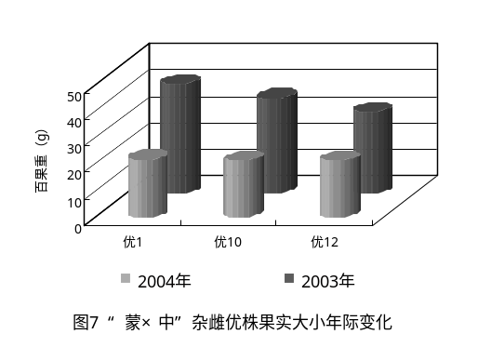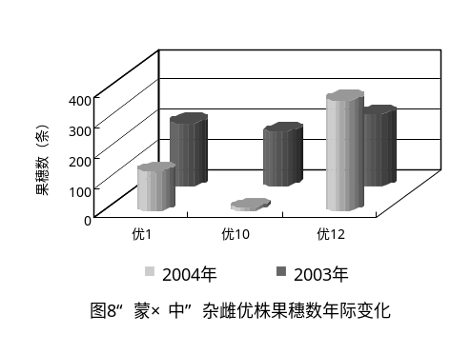
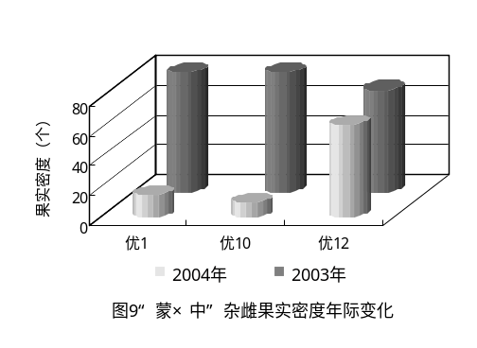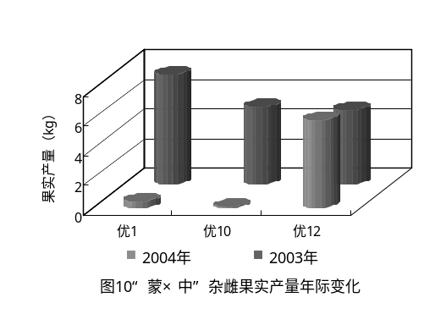
The reasons caused the fruit falling are two of them. One is the drought and the other is the lower capability for resistance of plants.
It well be know the drought will result in the fruit falling, not in seabukcthorn, but in most of the fruit trees^{[17] [18] [19] [20]}. The variation of different resistance within single plants are caused by the genetic re-combination by hybridization. In 2004, investigated 50 plants chosen freely from the filial population, fruit falling happened in about 2/3 plants. But very few plants had been found to have fruit falling within 50 investigated plants in sinensis population same year.
This show us the sinensis has a higher capability to resist drought condition, both to arid air condition and dry soil condition. In Jiuchenggong, not only less precipitation, but also heavy evaporation and poor soil raining water preserved. So it is obvious that drought air condition and poor soil environment caused the heavy fruit falling. But we hope we selected one best plant from filial population crossed by mongolica and sinensis.
Conclusion:
- the F1 generation population crossed by mongolica and sinensis can grow well and bear fruit under semi-arid ecological conditions;
- all the phyonetype features have a variation in F1 population compared with parents population, growth in height exceeds the parents population, more plants in F1 population, the weight of 100 fruit are over 20 g, the pedicel are longer than 2.5 mm, the mature time is early than sinensis, the thorns are much less than male population, under poor eco-condition, the productivity is similar to parent population. No disease has been found in F1 population.
- Selected plants are with fine features both parents, their growing better than parent population, fruit size and productivity are much bigger and higher than F1 and parent populations, the thorns are less than F1 population and sinensis population. The content of Vc and Ve are high by bio-chemical composition analysis.
- Drought have a great effect to fruit productivity of F1 population, so the forth more testing on their resistance need to be done under different eco-conditions, and then selected varieties with both more higher ability to resistance to poor eco-environment and high fruit productivity and fine quality.

